**P1 – Outline the web architecture and components which enable internet and web functionality**

**Introduction**

In this report, I will outline the web architecture and the components that are used for a web to function.

**Web architecture**

**Internet Service Providers (ISP)**

Internet service providers are companies who provide internet for the users. An example of an organisation that provide internet could be Virgin Media. They are many around the world. However, you have to pay to use their services. It could be around £10 to £20 per month. However, customers need to choose, which company that they would want for the internet. Each company’s internet could be faster or slower. However, if there is any problem concerning the internet, they can phone them for help. I have Virgin Media, and it is very good. The picture below shows the different companies that are in the UK, only.

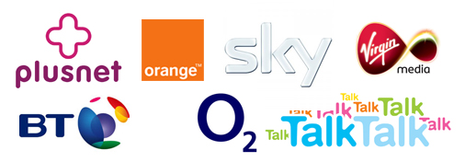

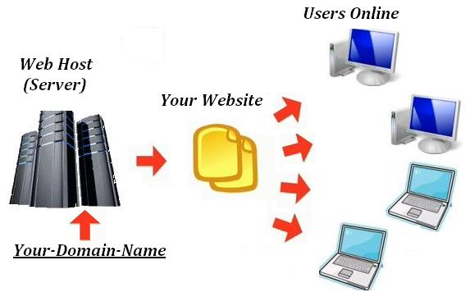**Web hosting services**

A web hosting service is an internet hosting service that allows any user, or company, to create websites. These services are important because it allows any user to create it. Those services can be limited. For example, putting in customised images cannot be allowed. A company runs these services. The image on the right shows how web hosting works. A company runs the server, and they monitor the progress that they have made.

**Domain structure**

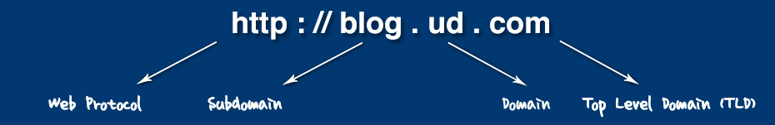Domain structure is broken down into levels. Domains are the names that is given at the end of a web-link. For example, [www.google.com](http://www.google.com). The .com is a domain and they are many of these around. These levels are top-level domain (TLD), and third-level domain. Each of these levels are used for different links. TLD is represented as a country code such as .us, .ca, and many more. Third-level domains are used to represent specific products, service or organisation. An example of a third-level domain is .ac.uk. This could be used for a college that is in the United Kingdom.

**Domain name registers**

Domain name registers are people who sell domains. An example of a domain name of where you can register is 123-reg.co.uk. First of all, you need to type in what your name will within the search button. Once this is done, you need to check its availability. This is done by the website showing if it is available. This is important, because any person can register their unique name of the website. Once this is available, the user needs to choose the domain. They can be many, for example, .org, and .biz. Once you have paid for it, you can finalise it and you own it.



**World Wide Web**

World Wide Web is abbreviated as WWW. This is an information system that allows users to use the hyperlink within documents and open up the specific link. It is called World Wide Web, because almost anyone can use it, and they can use it anywhere. It is used on any link that the user can find, and it is important the user uses this, because without it, the hyperlink would not work.

**Hardware Components**

**Routers**

A router is a device that takes incoming segment of data sent from over two networks. The data transmits through the router. It sends the data from the current location through the router to the destination it supposes to go. It tracks the destined location by using its IP address. Routers can be found in houses and small offices by passing data e.g. email. When the data has been sent, the router tries to find the best possible route to transmit the data. Wireless routers could be slow depending on where the computer is set in the house or small office. The internet transfers data using TCP/IP network, which is established for internet to communicate with each other. A router’s basic feature is to connect two networks together by transferring data. When data is send from one location to another, it is called ‘packets’. The function of the router is to ensure that the data has been travelled to the destination safely. It manages and controls the transferred data during the process. This is important as if it fails to transfer data, the transfer data would not reach the destination. Referring to figure 1.1, it demonstrates the diagram of a router. Each socket has its own job.

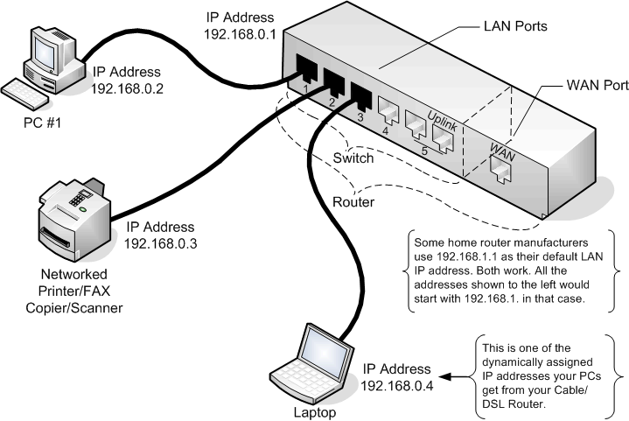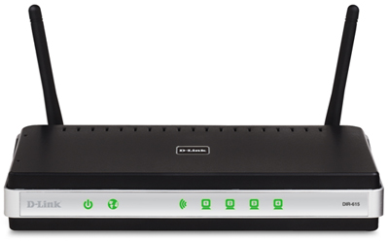

Figure 1.2

Figure 1.1

**Web server**

A web server processes requests via HTTP. This term can be referred to the whole server, or specifically to a software that accepts and supervises the HTTP requests. HTTP is a protocol that uses logical links to exchange or transfer information between nodes. The web server uses this, and any requests made, the web server gets involved. They are different types of web servers that are run, and some of them are the following: gaming, data storage, hosting websites, and many others. These use the process of requesting via HTTP. For example, gaming server. This uses web server, because they need to communicate online with other gamers. This uses the web server to make any requests to the other user. If one user wants to send a message to the other person, it would use the web server to send the message.

**HTTP**

Hypertext Transfer Protocol (HTTP) is a protocol that is found on the address bar that does two jobs. The first job is that it allows the user to access the information that is on the page and the other is that it transfers hypertext to the server when the process of communication is enabled.

**Proxy Server**

Proxyis a type of server that acts as a link between a workstation, user and the internet. It uses the internet so that it can seek resources from other servers. For example, a conversation between three people. The left asks to ask the right for the time. The message goes to the proxy which then the proxy tells the right person, “What is the time?” They reply in the same manner. Proxy is commonly used in businesses to enforce policies that are set by the administrator. They are three types of proxies that are used in the server:

* A forward proxy takes request from the network that it is being used on. It then forwards them onto the internet.
* An open proxy takes on both, from and to anywhere (internet).
* Reverse proxy takes request from the internet and forwards them to the current network that they are using.

FORWARD

OPEN

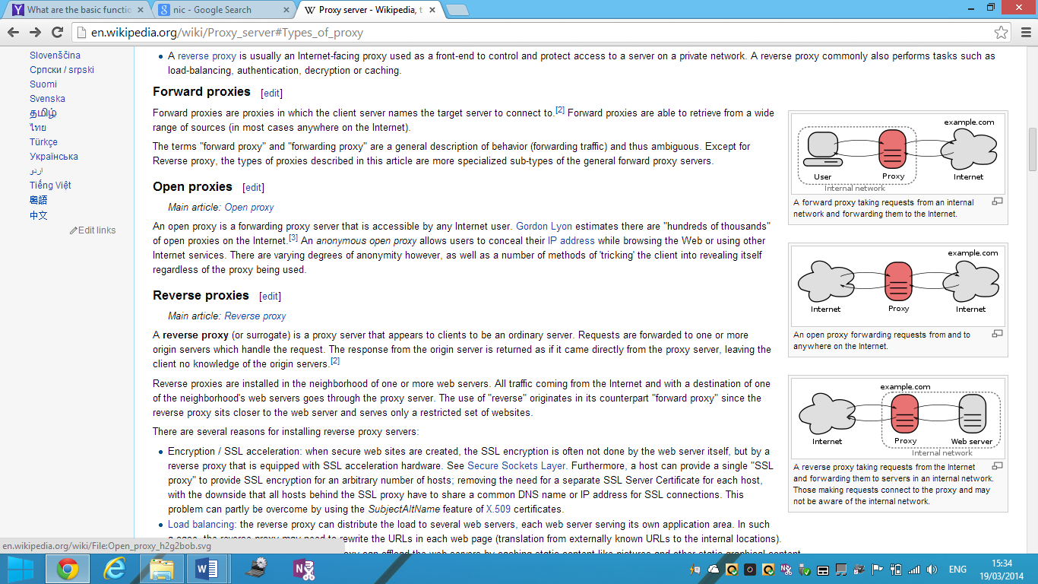

REVERSE



Figure 1.2

**Mail**

Mail server is a brilliant way to send information to another person. For example, if User A wants to send information to another person, this can be a letter or a normal message, he would only type it in the space provided, and it would work. The user needs his/her email address for communication to be enabled. **How it works?**

This mail server works by having two servers. Obviously, it would be one for incoming mail sever and outgoing mail sever. Outgoing mail sever could be known as SMTP, and incoming mail server could be known as POP3. As you may know, their jobs is to monitor, send, enable communication between the two.

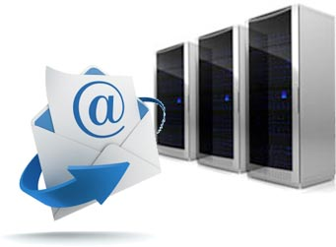

**Software Components**

**Browser software**

Browser software is an application that allows users to retrieve, present and traverse information resources on the internet. To find information, it is retrieved on the URL. You type in whatever you want to search, and the information is found. This is why, the internet, is useful. They are different types of browser software, and they are called: Internet Explorer, Mozilla Fox, Google Chrome, and others.



**Email software**

Email is an electronic software that enables communication through the internet. Email is like post office we send letters through post; however, electronic mail is a speedier adaptation when a client sends an email the other client gets it fast speed, yet although post office it takes days for the letter to arrive. Email has changed the way that we speak with others. It has provided for us the capacity to process work and data quicker and less expensive. One of our specialties can send data to other division holding data about our business. They are different types of email software such as Gmail, Hotmail, and others.

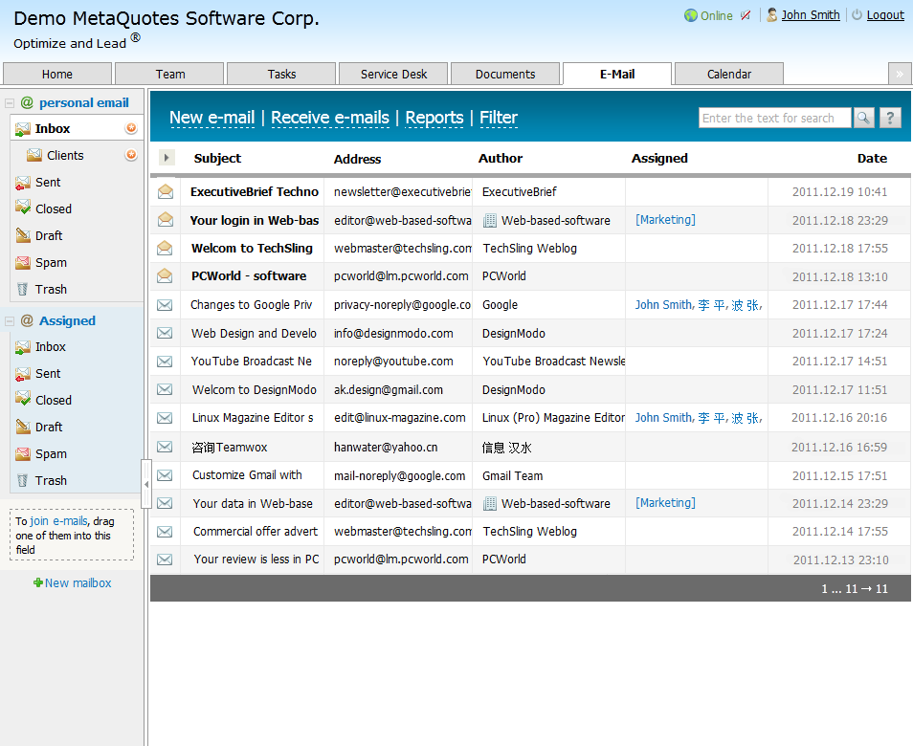

**Reference**

[**http://www.ask.com/technology/domain-structure-d0d1228b7dec946c**](http://www.ask.com/technology/domain-structure-d0d1228b7dec946c)